INDEX
S.No | Programs | Teacher’s Sign
1. | WAP to calculate 1’s complement of 8 bit number
2. | WAP to calculate 2’s complement of 8 bit number.
3. | WAP to find the sum of two 8 bit numbers.
4. | WAP to subtraction of two 8 bit numbers.
5. | WAP to find the largest among two numbers.
6. | WAP to find the largest number in an array.
7. | WAP to copy block of data from one location to another.
8. | Count the number of 1’s in an 8 bit number.
9. | WAP for linear search.
10. | WAP to count total even numbers in a series of ten  numbers.
11. | WAP for multiplication of two 8 bit numbers.
12. | WAP for division of two 8 bit numbers.
13. | WAP to calculate the sum of a series.

CALCULATE 1’S COMPLEMENT OF A 8 BIT NUMBER.
LDA C050
CMA
STA C051
HLT
# ORG C050
# DB 96H

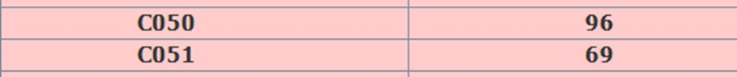
OUTPUT:-

PROGRAM 2:- WRITE A PROGRAM TO CALCULATE 2’S COMPLEMENT OF A 8 BIT NUMBER.
LDA C050
CMA
INR A
STA C051
HLT
# ORG C050
# DB 96H

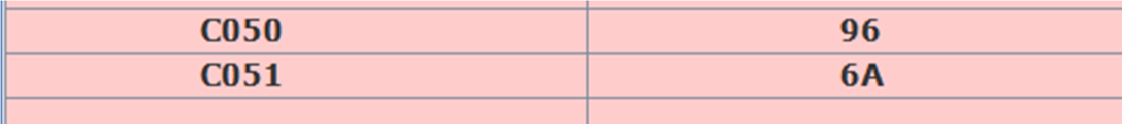
OUTPUT:-

FIND SUM OF TWO 8 BIT NUMBER.
LXI H,C050
MOV A,M
INX H
ADD M
STA C052
HLT
# ORG C050
# DB 55H,66H
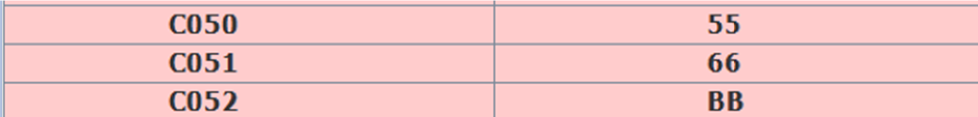
OUTPUT:-

PROGRAM 4:- WRITE A PROGRAM TO CALCULATE SUBTRACTION OF TWO 8 BIT NUMBER.
LXI H,C050
MOV A,M
INX H
SUB M
INX H
MOV M,A
HLT
# ORG C050
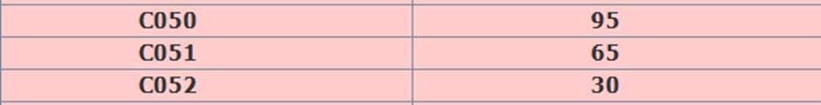
# DB 95H,65H OUTPUT:

FIND L RGEST AMONG TWO NUMBERS.
MVI A,34H
MVI B,25H
MOV C,A
CMP B
JNC LOOP
MOV A,B
STA C052
LOOP: MOV A,C
STA C053 HLT

OUTPUT:

FIND L RGEST NUMBER IN AN ARRAY.
MVI C,05
LXI H,2501
MOV A,M
DCR C
LOOP :INX H
CMP M
JNC AHEAD
MOV A,M
AHEAD: DCR C
JNZ LOOP
STA 2600
HLT
#ORG 2501
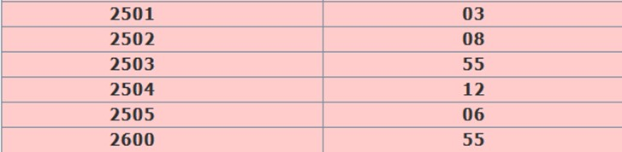
#DB 03,08,55H,12H,06

OUTPUT:-
COPY BLOCK OF DATA FROM ONE LOCATION TO ANOTHER.
# BEGIN 0000H
LXI H,C000H
LXI SP,B000H
MOV B,M
MOV C,M
INX H
SAVE:
MVI D,00H
MOV E,M
PUSH D
DCR C
INX H
JNZ SAVE
MOV C,B
MOV D,M
INX H
MOV E,M
MOV A,E
ADD C
DCR A
MOV E,A

XCHG COPY:
POP D
MOV M,E
DCR C
DCX H
JNZ COPY
HLT

OUTPUT:-
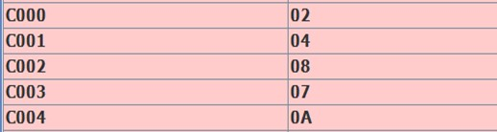
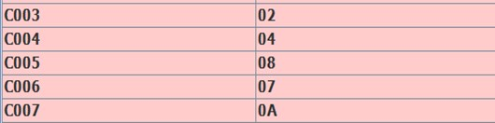
8 COUNT THE NUMBER OF 1’S

IN A 8 BIT NUMBER.
MVI B,00 MVI C,08
LDA 3000
RAR
JNC 200C
INR B
DCR C
JNZ 2007 MOV A,B STA 3001
HLT
#ORG3000H
#DB 05

OUTPUT:-

PROGRAM 9:- WRITE A PROGRAM FOR LINEAR SEARCH.
LXI H,2040
MOV B,M
LXI H,2050
MVI D,0A
NEXT: MOV A,M
CMP B
JZ STOP
INX H
DCR D
JNZ NEXT
LXI H,2060
MVI M,00
HLT
STOP: LXI H,2060
MVI M,01
HLT
#ORG 2040
#DB 02
#ORG 2050
#DB 03,05,02,10H,12H,02,03,01,09,08

OUTPUT:-
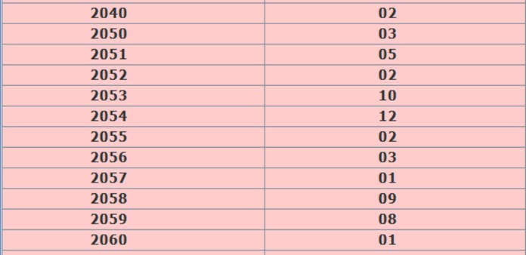

PROGRAM 10:- WRITE A PROGRAM TO COUNT TOTAL EVEN NUMBERS IN A SERIES OF 10 NUMBERS.
2000: LXI H,204F
2003: MVI C,00
2005: MVI D,0A
2007: INX H
2008: MOV A,M
2009: ANI 01
200B: JNZ 200F
200E: INR C
200F: DCR D
2010: JNZ 2007
2013: MOV A,C
2014: STA 3050
2017: HLT
#ORG 2050
#DB 02,03,08,01,07,04,0A,3B,05,06 OUTPUT:-
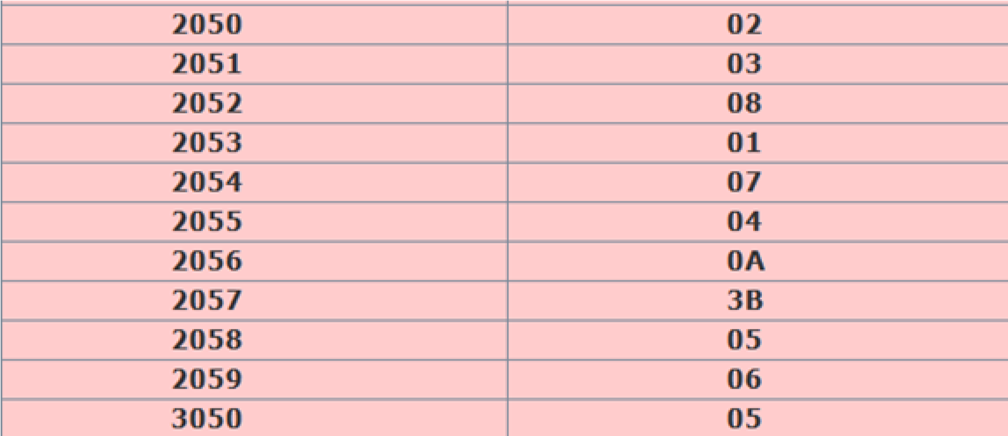

PROGRAM 11:- WRITE A PROGRAM FOR MULTIPLICATION OF TWO 8 BIT NUMBERS.
# ORG 2000H
# BEGIN 2000H
LHLD 2501
XCHG
LDA 2503
LXI H,0000
MVI C,08
LOOP: DAD H
RAL
JNC AHEAD
DAD D
AHEAD: DCR C
JNZ LOOP
SHLD 2504
HLT
# ORG 2501H
# DB 84H,00H,56H

OUTPUT:-
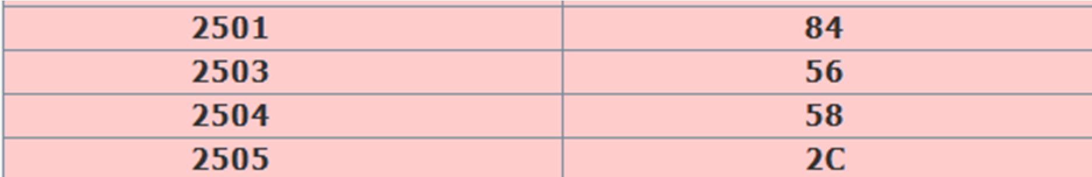

PROGRAM 12:- WRITE A PROGRAM FOR DIVISION OF TWO 8 BIT NUMBERS.
# ORG 2000H
# BEGIN 2000H
LHLD 2501
LDA 2503
MOV B,A
MVI C,08
LOOP: DAD H
MOV A,H
SUB B
JC AHEAD
MOV H,A
INR L
AHEAD: DCR C
JNZ LOOP
SHLD 2504
HLT
# ORG 2501H
// LSB OF DIVIDEND , MSB OF DIVIDEND , DIVISOR
# DB 9BH,48H,1AH
OUTPUT:-
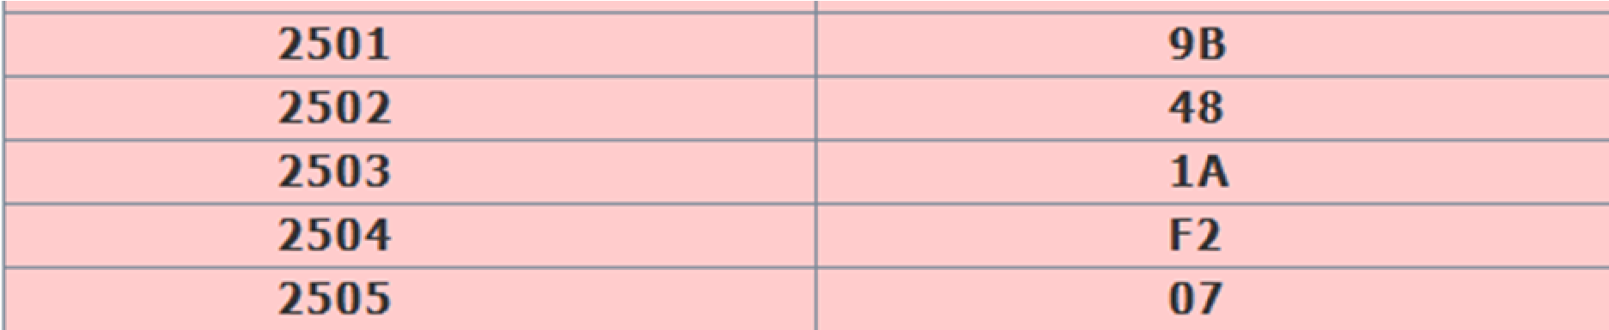

PROGRAM 13:- WRITE A PROGRAM TO CALCULATE SUM OF A SERIES.
#BEGIN 2001H
MVI C,05
MVI B,00
LXI H,2001
DCR C
DCR C
LOOP: INX H
ADD M
JNC SKIP
INR B
SKIP: DCR C
JNZ LOOP
STA 3001 MOV A,B
STA 3002
HLT
#ORG 2001H
#DB 01,02,03,04,05

OUTPUT:-
